
TRINITY METHODIST CHURCH, HARROGATE
A crèche is available for any children who wish to join them during the service.
www.trinityharrogate.org.uk
SUNDAY 10th JUNE 2018
10:30am J Briggs (MHA)
Stewards: Anthea Shenton & Carol Allan
Readers: Geoff Runcorn & Jane Shaw
Organist: Judith Yeats Flowers: Wedding
4:00pm Messy Church – Mr M Lunn
TUESDAY 12th JUNE 2018
12 noon Luncheon Club
7:15pm Steel band

FRIDAY 15th JUNE 2018
10:00am Trinity Tots

SUNDAY 17th JUNE 2018
10:30am Rev G Robertson
Stewards: Helen Fairless & Margaret Moorhouse
Readers: Derek Harper & Janet Tipping
Organist: Philip Goodwin Flowers: Marion Green

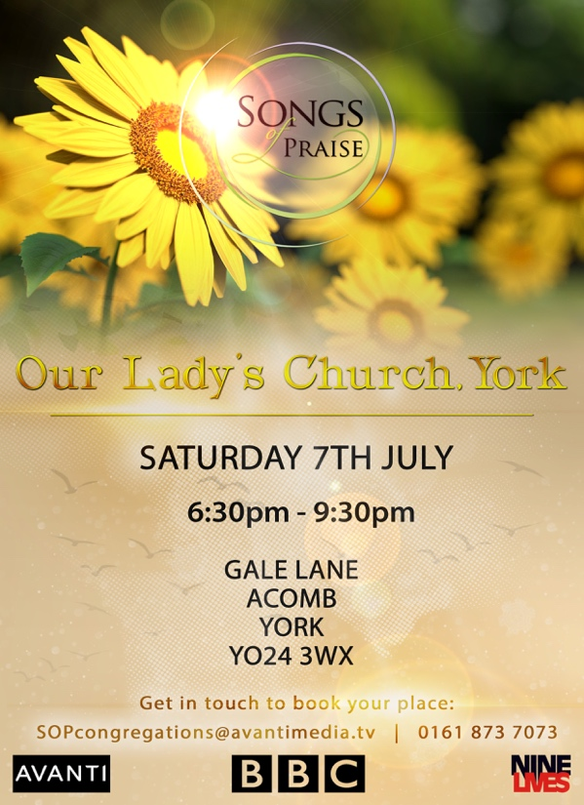
TRINITY NOTICES – Please let Tracey have any items for Sunday 17th June by Tuesday 12th June. She can be contacted on **** or by e-mail at ****@talktalk.net Please note: notices are on the website each week. www.trinityharrogate.org.uk Please email with amends or additions. TRINITY IS ON FACEBOOK Search for Trinity Methodist Church, Harrogate.
HOUSE FELLOWSHIP GROUP – Next one 25th July at 7.45pm 50 Bogs Lane, Harrogate, HG1 4EB.

CHRISTIAN AID COLLECTION 2018 Trinity raised £331.50 for Christian Aid this year as a result of the Church collection and the Big Breakfast coffee morning last Saturday. Thanks to all who contributed money and to those who organised and served at the Big Breakfast.

Christian Aid is a Church charity run by 41 different Church denominations and run from a Church building in London. It does not give any money to governments or government agencies but rather works through local Churches on projects which bring long term improvements to impoverished communities. It is therefore deserving of our support and encouragement.

NOAH’s ARK PRE-SCHOOL would like to recruit a new member for 2.5 days per week. Please contact Doreen Whittaker noahsark@graciousstreetmethodist.org.uk or pop in for details.

CHURCH COUNCIL MEMBERS: I am required to give you notice and ask for your attendance at Trinity Methodist Church for a meeting of the Church Council to be held at 7.30 pm on Thursday 21 June 2018. If you have any other business for this meeting, could you please advise Ben by 14 June. Please also advise myself if you are unable to attend, thank you. Adele Goodall, Church Council Secretary

DISTRICT ORDINANDS TESTIMONY SERVICE on Sunday, 17th June at Pocklington Methodist Church at 4pm. This is an important service within the District, especially for our three ordinands, Ann Fox (Nidd Valley), John Schofield (York) and David Spiers (Hull (Centre and West). The preacher will be the Revd Jonathan Dean, from Queens College.

EVENTS at Woodlands: How to bring the outdoors in? at Woodlands on 24th June 2-4:30pm

St Robert of Knaresborough and the Making of a Saint in the 800th anniversary year of the death of St Robert. Examining the shared heritage of the saints and what it means to be a truly whole human being: arranged by the Ripon Support Group of the Anglican Centre in Rome on 16th June 2018 10am – 3.00pm@ St John the Baptist Church, Knaresborough and at St Robert’s Cave “The Life and Times of St Robert” with Peter Lacey and Dr Ruth Beckett. Contribution to the cost of the day £15 – Free to students
THE YORKSHIRE NORTH AND EAST METHODIST DISTRICT SAFEGUARDING GROUP is seeking new members. They are responsible for the promotion and implementation of effective safeguarding provision across all Methodist Churches within the Yorkshire North and East Methodist District. New members to contribute towards its work, which includes: • Discussing programmes of awareness, training and ways of promoting Methodist safeguarding policies, guidance and good practice throughout the District; • Providing support and guidance to the District Safeguarding Officer, including confidential advice and discussion about casework; • Reporting to the Methodist District Policy Committee; • Involvement in events and meetings including training events, regional conferences and meetings associated with safeguarding casework; and • Convening quarterly District Safeguarding Group business meetings, which currently comprise lay and ordained colleagues with safeguarding experience or other relevant professional backgrounds and which are chaired by Mr Rod Young, a retired NHS Biochemist and Magistrate. If you are interested in contributing towards this work then please email Siân Henderson (Yorkshire North and East District Administrator at admin@yorkshirenemethodist.org) to express your interest, outlining any relevant experience and background you might have in this area of work by Wednesday 27 June 2018.
Minister – Rev Ben Clowes – Tel: 870977 E-mail: revbclowes@gmail.com
Children’s & Families Worker : Matthew Lunn Tel: 501533 or email: matt.lunn24@btinternet.com
ALERT - YOUNG and YOUNG AT HEART We are planning to hold a Sunday afternoon tea on Sunday 15th July 3 p.m. - 5 p.m. We thought it would be fun to have some entertainment….SO….. if you would like to take part please have a word with Sue Covill or Lynda Dale and we will arrange the afternoon programme. It will also be an opportunity to say goodbye and thank you to Matthew and Helen Lunn. Nearer the time, there will be a list on the notice board for people to sign, so we have an idea of how many to cater for. Many thanks.
SERVICE OF THANKSGIVING FOR 70 YEARS OF THE NATIONAL HEALTH SERVICE Sunday 8th JULY 2018 at 2pm to 2.45pm An offering will be taken during the service to support the work of the Chaplaincy Department at Harrogate District Hospital.
Minister – Rev Ben Clowes – Tel: 870977 E-mail: revbclowes@gmail.com
Children’s & Families Worker : Matthew Lunn Tel: 501533 or email: matt.lunn24@btinternet.com

