
TRINITY METHODIST CHURCH, HARROGATE
A crèche is available for any children who wish to join them during the service.
www.trinityharrogate.org.uk
SUNDAY 10th MARCH 2019
10:30am Mr M Greenberg
Stewards: Margaret Moorhouse & Sue Covill
Readers: Derek Harper & Doreen Swain
Organist: Jean Clay Flowers: - Mary Briggs
4:00pm Messy Church

TUESDAY 12th MARCH 2019
12 noon Luncheon Club
7:15pm Steel band

FRIDAY 15th MARCH 2019
10:00am Trinity Tots

SUNDAY 17th MARCH 2019
10:30am Mrs H Evison
Stewards: Anthea Shenton & Carol Allan
Readers: Mary Briggs & Sue Covill
Organist: Philip Goodwin Flowers: - Rosemary Temple

TRINITY NOTICES – Please let Tracey have any items for Sunday 17th March by Tuesday 12th. She can be contacted on **** or by e-mail at ****@talktalk.net Please note: notices are on the website each week. www.trinityharrogate.org.uk Please email with amends or additions. TRINITY IS ON FACEBOOK Search for Trinity Methodist Church, Harrogate.
PRAYER TIME - each week a small group of people faithfully pray for the church, the preacher, the service and more at 10.15am in one of the side rooms for 5-10 minutes.
EARLY COMMUNION - Every month on the last Sunday of the month there is a small group who meet for a short, reflective communion service at 9am. All are welcome to join us.

COLLECTIONS FOR FEBRUARY
w/c 3/2/19 £251.13; 10/2/19 £508.82; 17/2/19 £230.20; 24/2/19 £230.90
Total collections including bank transfers £1,976
Amount required to break even operationally £2,820
HOUSE FELLOWSHIP GROUP – Next one on 20th March at 7.45pm 50 Bogs Lane, Harrogate, HG1 4EB. Future ones 10th April; 22nd May; 19th June and 17th July.
Invitation to your Church – The People’s Passion – Sunday 14th April (Palm Sunday) at 3pm.
A powerful piece of theatre and worship. From the roaring crowd at the entry into Jerusalem to the moving drama of the crucifixion, a chorus of voices tell the Easter story. There’s a part for everyone to play and no rehearsal needed.
Suitable for adults and children so long as they can read, this is led by the renowned Riding Lights Theatre Company from York, who will be our resident drama team for the event.
We are offering free tickets for the afternoon as a way of marking Palm Sunday together, available from 1 March on the booking site at http://www.springharvest.org/harrogate
FLOURISH You can now make bookings for Flourish tickets here: (free) https://www.eventbrite.co.uk/e/flourish-the-yorkshire-north-east-district-weekend-tickets-55019533907?aff=eac2 Fri 18 Oct 19:30 to Sun 20 Oct 13:00 at Scarborough Spa YO11 2HD
Minister – Rev Ben Clowes – Tel: 870977 E-mail: revbclowes@gmail.com
Children’s & Families Worker : Jaynie Kendall



The Sound of Silence
A district day to explore and reflect on the Cistercian tradition and the life and writings of Aelred, abbot of Rievaulx (1147-1167)
Saturday July 20th 2019 10 am – 4 pm
based at the Methodist Chapel in Rievaulx with admission to the Abbey.

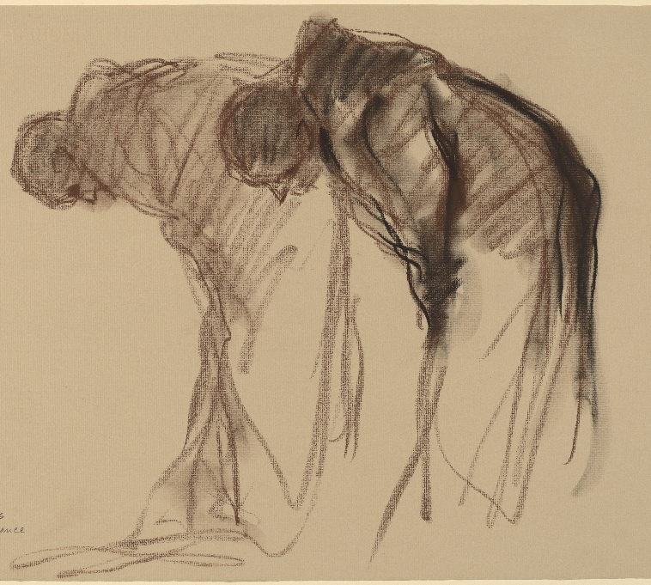
Abbaye de Solesmes. Stanley Rosman Used by permission
The day will be led by the Revd. Dr. Kenneth Carveley who is a church historian and liturgist with the Mirfield Liturgical Institute and a Cistercian scholar who has researched and taught the Cistercian tradition over many years.
Cost £5 per person. Parking: There is limited parking at the chapel, and further parking at the Abbey. Lunch : bring your own picnic lunch, tea and coffee will be available, or use the café at the Abbey.
Book with Siân Henderson at the Yorkshire North & East District Office, 28 The Green, Acomb, York, YO26 5LR. admin@yorkshirenemethodist.org. 01904 786275

Church AGM – On 31st March 2019 the Church AGM is due to take place. This year things will be done slightly differently in that the meeting is going to take place during the Sunday Morning Service which will be a café church. Coffee will be served at the start and, as this particular Sunday is Mothering Sunday and Trinity’s 140th Anniversary, the service will last approximately an hour and a half. There will be some colouring activities and toys available for younger children, supervised by their parents, during the part of the service that includes the AGM. Adele Goodall, Church Secretary.
Noah’s Ark 
are having a
Coffee Morning on
Saturday 23rd March 10am-12noon
The Bridge – Gracious Street Methodist Church
Come & join us
Painting Pots will be there too, why not decorate something for Mother’s Day?
Hope to see you!
Raising funds for Noah’s Ark Pre-School

