SAFEGUARDING - There will be another session of the Safeguarding course on Monday 26th November at Woodlands church starting at 7pm.  VOLUNTEERS - Any volunteers wishing to assist with refreshments for a couple of hours over the Christmas Tree Festival weekend would be greatly appreciated. If you are able could you please add your name to the sheet displayed on the church notice board, thank you.  NETWORK OPEN MEETING For everyone  Tuesday 20 November 10.15am  Come and hear John Shackleton’s remarkable story and achievements  entitled  ‘Not for the faint hearted’  Coffee will be served before the meeting  John runs a charitable organisation which raises money to deliver emergency vehicles and other urgently needed equipment to caring organisations in Eastern Europe and beyond.  To date he has made 40 trips have been made to deliver ambulances and 2 fire engines to Russia, Armenia, Poland, Bosnia, Kosovo, Croatia, Afghanistan, Turkey, Albania, Bulgaria, Macedonia, Georgia, Azerbaijan, Romania, Moldavia, Transylvania, Latvia and Bohemia.  A plate will be available for any donations  Please enter by the left hand side door for Room 1  MINCE PIES - Donations of Mince Pies would be greatly received to serve as refreshments on the evening of 30th November during the Harrogate Brass Band Concert at 7.30 pm.  WEST PARK URC CHRISTMAS LUNCH - Our friends at West Park United Reformed Church are having their Christmas lunch on Friday 7th December at the Cairn Hotel. The cost will be £14. Would anyone wishing to attend please fill in a menu form available at the coffee table today. Please return completed forms to Albert Johnston. |  | TRINITY METHODIST CHURCH, HARROGATE  http://www.trinityharrogate.org.uk/  A crèche and Sunday School are available for any children who wish to  join them during the service.    REMEMBRANCE SUNDAY 11TH NOVEMBER  10:30 am Rev Gillian Robertson  06:30 pm Service of Remembrance and Thanksgiving at Gracious Street Methodist Church  Stewards: Frances Runcorn & Shirley Fatkin  Readers: Derek Harper & Janet Tipping  Organist: Jean Clay  Flowers: Freda Fretwell  TUESDAY 13TH NOVEMBER  12 noon Trinity Luncheon Club  WEDNESDAY 14TH NOVEMBER  07:45 pm House Group – 53 Beckwith Road, Harrogate  FRIDAY 16TH NOVEMBER  01:30 pm Trinity Tots  SUNDAY 18TH NOVEMBER  10:30 am Rev Arnold Clay  BOB WISE - Bob’s funeral will take place at Harlow Hill on Friday 16th November at 11.30am. We give thanks for his life and remember his family in our prayers.  SOCIAL AND AMENITIES COMMITTEE - We are in need of donations of food and help with refreshments for the Christmas Tree Festival. I would like to draw your attention to the list on the notice board in the Foyer. Your help would be greatly appreciated. Many thanks. Margaret Rodham  THE CHRISTMAS SERVICES ARE AS FOLLOWS:  December 16th 10.30 Christingle and Nativity with Band  December 16th 4 pm Nine Lessons and Carols  December 23rd - 10.30 Family Carol service with band and organ.  Minister – Rev Mark Godfrey – Tel: 01423 503551 – E-mail: revmgodfrey@gmail.com
HARROGATE BRASS BAND CONCERT  Trinity Methodist Church  30TH November 2012  7.30 p.m.  Tickets at £5.00 each (children free)  available from Lynda Dale, Jenny Godfrey or Anthea Shenton  CHRISTMAS APPEAL ON BEHALF OF HARROGATE HOMELESS PROJECT  Once again this year we are to hold a Christmas appeal for the work of the Harrogate Homeless Project.  The appeal will take place in the Victoria Shopping Centre between Monday 3rd and Saturday the 8th of December.  We will be collecting there every day during that week between 9.30am and 4.pm, and possibly on the late night opening on the Thursday.  If you are able to help in this collection for one hour a day or perhaps even more, then please can you contact me either by phone or by email. 01423 864571 or elaine@friendsofhhp.co.uk  Last year the response from the members of the Harrogate community to steward for this very local charity was amazing. If you can help to steward during this appeal we will be very grateful  The Project has launched it’s “No Second Night Out” scheme this year, which is an attempt to prevent anyone sleeping rough on the streets of the Harrogate District for a second night.  To do this the Project with the assistance and support of Harrogate Council and private landlords will offer a bed and full assistance for those who wish to get themselves back into secure housing.  This of course is another strain on the resources of the Project meaning that collections like this are absolutely essential.  If you can help in any way please contact me. Thank you Elaine Harrison | Knaresborough HG5 8DS | 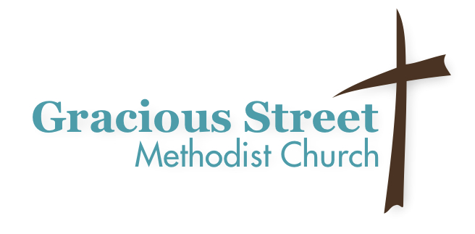  The Rev Gail Hunt  Tel: 01423 863298  Invitation to a Service of Remembrance and Thanksgiving.  Sunday 11th November 6:30 pm  Please join us for the above service which will be a time of reflection and remembrance of loved ones who have died. During this time of worship there will be an opportunity to light a candle in memory of a loved one, and many have found this service to be one of comfort and renewal.  Refreshments will be served after the service.  All are welcome and if you know others who would like to come please pass this invitation on.  CHRISTMAS TREE AND ANGELS FESTIVAL  Times to visit the tree festival:  Saturday 1st December - 10 am - 6 pm  Sunday 2nd December - 12 noon - 4 pm  Lunches, tea, coffee and cakes will be available.

