
TRINITY METHODIST CHURCH, HARROGATE
A crèche is available for any children who wish to join them during the service.
www.trinityharrogate.org.uk
SUNDAY 12th MAY 2019
10:30am Mr A Brown
Stewards: Lynda Dale & Carol Allan
Readers: Janet Tipping & Doreen Swain
Organist: Jean Clay Flowers: - Sue Covill
4:00pm Messy church – Rev B Clowes

TUESDAY 14th MAY 2019
12 noon Luncheon
7:15pm Steel band

FRIDAY 17th MAY 2019
10:00am Trinity Tots

SUNDAY 19th MAY 2019
10:30am Rev B Clowes
Stewards: Anthea Shenton & Sue Covill
Readers: Ann Francis & Anthea Shenton
Organist: Lynn Watson Flowers: - Doreen Swain
4:00pm Messy church – Rev B Clowes

TRINITY NOTICES – Please let Tracey have any items for Sunday 19th May by Tuesday 14th. She can be contacted on **** or by e-mail at ***@talktalk.net Please note: notices are on the website each week. www.trinityharrogate.org.uk Please email with amends or additions. TRINITY IS ON FACEBOOK Search for Trinity Methodist Church, Harrogate.
PRAYER TIME - each week a small group of people faithfully pray for the church, the preacher, the service and more at 10.15am in one of the side rooms for 5-10 minutes.
EARLY COMMUNION - Every month on the last Sunday of the month there is a small group who meet for a short, reflective communion service at 9am. All are welcome to join us.
HOUSE FELLOWSHIP GROUP – Next one on 22nd May at 7.45pm 50 Bogs Lane, Harrogate, HG1 4EB. Future ones 22nd May; 19th June and 17th July.
THANK YOU A lovely sum of £84.50 was raised for Christian Aid by those who attended the soup lunch on Tuesday – thank you to Waitrose who provided the vegetables.
The “Chorus Crew” in Concert - Folk Songs & Sea Shanties
The Chorus Crew have been singing together for about three years now. We perform regularly in the Harrogate and Knaresborough district, singing a wide range of unaccompanied folk songs and sea shanties. We love singing for an audience, sharing information about the songs, and encouraging audience participation. Sunday 2nd June 2019 @ 3.00pm Admission £5 Children Free - Pay at the door In aid of All We Can - Light refreshments - Everyone is most welcome.

Bilton have organised a bus for Grace’s ordination at Coventry Central Hall at 4pm on 30th June. There are 5 spaces left on the bus and a few more tickets, so if you are planning on going and need a ticket or transport, please contact Judith Dewhirst asap.
Over the next few months the Nidd Valley Circuit is pleased to be hosting a Student Minister, Stephen Spain. Stephen is currently completing his first part-time year of Ministerial Formation at Queen's in Birmingham and is seconded to us as a circuit from now until the end of July. Stephen will be doing active work in the circuit alongside the Staff team but also being sent out to do work by himself. His placement only covers 60 hours and so not everyone will encounter him but if you meet him, please make him welcome and support him in his training experience with us. The Staff team are putting together a programme of activities for him and he is preaching on our Summer plan. Do pray for him as he works alongside us. God Bless Ben
Hampsthwaite are replacing their chairs and would like to offer theirs to anyone who can use them, churches, community groups, individuals. Grace Cauldwell, Methodist Minister- Nidd Valley Circuit
01423 562542; 07341 960506
ENCIRCLED IN CARE, A course for all, looking at areas where we can improve our care for one another. The six sessions will be held at Trinity 7.15 pm - 8.45 pm on the following dates:- Wednesday 8th May, Tuesday 14th May, Tuesday 21st May, Wednesday 5th June, Wednesday 12th June and Thursday 20th June. If you are interested please sign on the list in the foyer. Many thanks.
SAVE THE DATE – The Call. On Saturday 6th July 2019, the Nidd Valley Circuit will host The Call tour at Wesley Centre. An evening of music and celebration led by musician, composer and worship leader, Matt Beckingham. Please put this date in your diary. More details to follow.....
FLOURISH You can now make bookings for Flourish tickets here: (free) https://www.eventbrite.co.uk/e/flourish-the-yorkshire-north-east-district-weekend-tickets-55019533907?aff=eac2 Frdayi 18 Oct 19:30 to Sun 20 Oct 13:00 at Scarborough Spa YO11 2HD

The Sound of Silence
A district day to explore and reflect on the Cistercian tradition and the life and writings of Aelred, abbot of Rievaulx (1147-1167)
Saturday July 20th 2019 10 am – 4 pm
based at the Methodist Chapel in Rievaulx with admission to the Abbey.

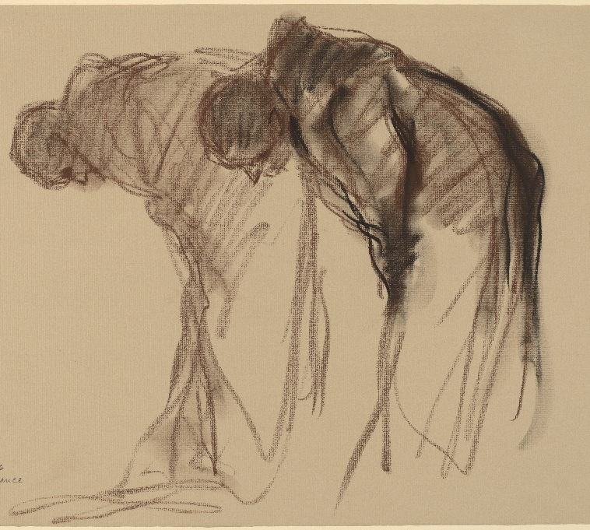
Abbaye de Solesmes. Stanley Rosman Used by permission
The day will be led by the Revd. Dr. Kenneth Carveley who is a church historian and liturgist with the Mirfield Liturgical Institute and a Cistercian scholar who has researched and taught the Cistercian tradition over many years.
Cost £5 per person. Parking: There is limited parking at the chapel, and further parking at the Abbey. Lunch : bring your own picnic lunch, tea and coffee will be available, or use the café at the Abbey.
Book with Siân Henderson at the Yorkshire North & East District Office, 28 The Green, Acomb, York, YO26 5LR. admin@yorkshirenemethodist.org. 01904 786275

Nidd Valley Circuit
Vacancy - Lay Pastor
The Nidd Valley Circuit is seeking to appoint a Lay Pastor to report to and work alongside the Circuit Superintendent Minister in Trinity and Pannal Churches.

The role will involve three main areas of duty; pastoral duties, worship leading and projects and initiatives.

The pastoral duties will include home and hospital visits and attendance at pastoral meetings. The successful applicant will also be required to lead worship and other devotional gatherings as well as regularly attending worship at both churches. In addition, the jobholder will work alongside the Presbyter on specific missions and projects as required. There may be some requirement to attend meetings as the Ministry Team representative.

The hours of work are 9 to 12 per week and the salary is £23,500 per annum, pro rata. The post has an initial fixed term of two years.

If any interested parties would like to request an informal meeting ahead of the application process please contact Heather Memmott, Circuit HR Officer on 07515701548 or by email; heatherm71@btinternet.com

If you would like to receive an application pack, please email Heather at the address above.
Closing Date for Applications: Monday 20th May 12 noon. Interviews to take place Thursday 6th June

Minister – Rev Ben Clowes – Tel: 870977 E-mail: revbclowes@gmail.com
Children’s & Families Worker : Jaynie Kendall

