
TRINITY METHODIST CHURCH, HARROGATE
A crèche is available for any children who wish to join them during the service.
www.trinityharrogate.org.uk
SUNDAY 14th JULY 2019
10:30am Local Arrangement
Stewards: Margaret Moorhouse & Cliff Anderton
Readers: Ann Francis & Janet Tipping
Organist: Judith Yates Flowers: - Church Flowers
16:00 Messy Church – Miss A Cooley

TUESDAY 16th JULY 2019
12 noon No Luncheon Club – closed for the Summer break
7:15pm Steel band

FRIDAY 19th JULY 2019
10:00am Trinity Tots

SUNDAY 21st JULY 2019
10:30am Mrs C Webster
Stewards: Anthea Shenton & Mary Briggs
Readers: Mary Briggs & Anthea Shenton
Organist: Philip Goodwin Flowers: - Jean Goldsack

TRINITY NOTICES – Please let Tracey have any items for Sunday 21st July by Tuesday 16th. She can be contacted on **** or by e-mail at ****@talktalk.net Please note: notices are on the website each week. www.trinityharrogate.org.uk Please email with amends or additions. TRINITY IS ON FACEBOOK Search for Trinity Methodist Church, Harrogate.

The Sound of Silence
A district day to explore and reflect on the Cistercian tradition and the life and writings of Aelred, abbot of Rievaulx (1147-1167)
Saturday July 20th 2019 10 am – 4 pm
based at the Methodist Chapel in Rievaulx
with admission to the Abbey.

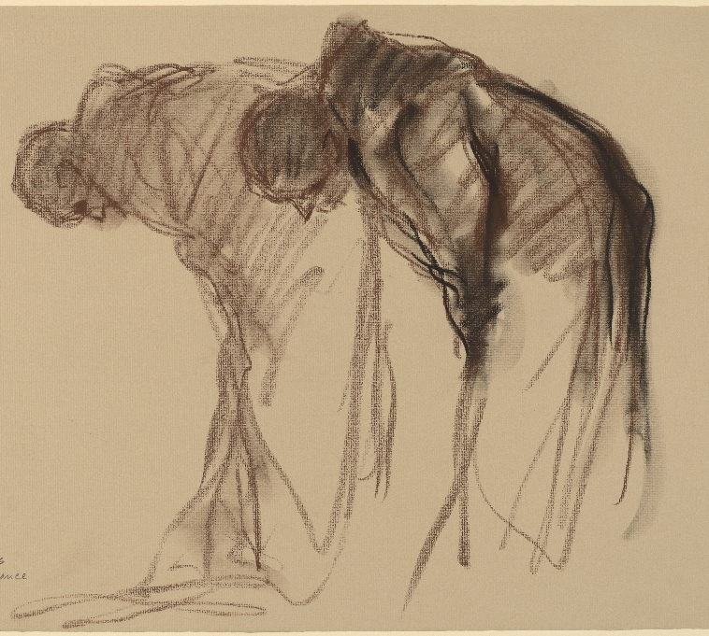
Abbaye de Solesmes. Stanley Rosman Used by permission
The day will be led by the Revd. Dr. Kenneth Carveley who is a church historian and liturgist with the Mirfield Liturgical Institute and a Cistercian scholar who has researched and taught the Cistercian tradition over many years.
Cost £5 per person. Parking: There is limited parking at the chapel, and further parking at the Abbey. Lunch : bring your own picnic lunch, tea and coffee will be available, or use the café at the Abbey.
Book with Siân Henderson at the Yorkshire North & East District Office, 28 The Green, Acomb, York, YO26 5LR. admin@yorkshirenemethodist.org. 01904 786275

PRAYER TIME - each week a small group of people faithfully pray for the church, the preacher, the service and more at 10.15am in one of the side rooms for 5-10 minutes.
EARLY COMMUNION - Every month on the last Sunday of the month there is a small group who meet for a short, reflective communion service at 9am. All are welcome to join us.
HOUSE FELLOWSHIP GROUP – Next one on 21st August at 7.45pm 50 Bogs Lane, Harrogate, HG1 4EB.
WORSHIP: FOUNDATIONS an introduction to preparing and leading worship in the Methodist Church at Bilton Area Methodist Church at 7:30pm on 18 July. Led by Mr Andrew Brown and Rev Ann Fox. To register email ann.fox@methodist.org.uk
Community and Outreach Lay Worker at The Methodist Church in Pocklington. The post is funded for three years and will initially be based at Pocklington Methodist Church. Salary £20,000, based on 37 hour week Closing Date: 14th July 2019 Rev Neville Simpson, Tel No. 01759 303354. Email: revnevillesimpson@gmail.com
ENCIRCLED IN CARE, A course for all, looking at areas where we can improve our care for one another. Last one will be held at Trinity 7.15 pm - 8.45 pm on 31st July.
FLOURISH You can now make bookings for Flourish tickets here: (free) https://www.eventbrite.co.uk/e/flourish-the-yorkshire-north-east-district-weekend-tickets-55019533907?aff=eac2 Friday 18 Oct 19:30 to Sun 20 Oct 13:00 at Scarborough Spa YO11 2HD
Minister – Rev Ben Clowes – Tel: 870977 E-mail: revbclowes@gmail.com
Children’s & Families Worker : Jaynie Kendall

TRINITY METHODIST CHURCH, HARROGATE
A crèche is available for any children who wish to join them during the service.
www.trinityharrogate.org.uk
SUNDAY 14th JULY 2019
10:30am Local Arrangement
Stewards: Margaret Moorhouse & Cliff Anderton
Readers: Ann Francis & Janet Tipping
Organist: Judith Yates Flowers: - Church Flowers
16:00 Messy Church – Miss A Cooley

TUESDAY 16th JULY 2019
12 noon No Luncheon Club – closed for the Summer break
7:15pm Steel band

FRIDAY 19th JULY 2019
10:00am Trinity Tots

SUNDAY 21st JULY 2019
10:30am Mrs C Webster
Stewards: Anthea Shenton & Mary Briggs
Readers: Mary Briggs & Anthea Shenton
Organist: Philip Goodwin Flowers: - Jean Goldsack

TRINITY NOTICES – Please let Tracey have any items for Sunday 21st July by Tuesday 16th. She can be contacted on **** or by e-mail at ***@talktalk.net Please note: notices are on the website each week. www.trinityharrogate.org.uk Please email with amends or additions. TRINITY IS ON FACEBOOK Search for Trinity Methodist Church, Harrogate.

The Sound of Silence
A district day to explore and reflect on the Cistercian tradition and the life and writings of Aelred, abbot of Rievaulx (1147-1167)
Saturday July 20th 2019 10 am – 4 pm
based at the Methodist Chapel in Rievaulx
with admission to the Abbey.

Abbaye de Solesmes. Stanley Rosman Used by permission
The day will be led by the Revd. Dr. Kenneth Carveley who is a church historian and liturgist with the Mirfield Liturgical Institute and a Cistercian scholar who has researched and taught the Cistercian tradition over many years.
Cost £5 per person. Parking: There is limited parking at the chapel, and further parking at the Abbey. Lunch : bring your own picnic lunch, tea and coffee will be available, or use the café at the Abbey.
Book with Siân Henderson at the Yorkshire North & East District Office, 28 The Green, Acomb, York, YO26 5LR. admin@yorkshirenemethodist.org. 01904 786275

PRAYER TIME - each week a small group of people faithfully pray for the church, the preacher, the service and more at 10.15am in one of the side rooms for 5-10 minutes.
EARLY COMMUNION - Every month on the last Sunday of the month there is a small group who meet for a short, reflective communion service at 9am. All are welcome to join us.
HOUSE FELLOWSHIP GROUP – Next one on 21st August at 7.45pm 50 Bogs Lane, Harrogate, HG1 4EB.
WORSHIP: FOUNDATIONS an introduction to preparing and leading worship in the Methodist Church at Bilton Area Methodist Church at 7:30pm on 27 June, 11 July & 18 July. Led by Mr Andrew Brown and Rev Ann Fox. To register email ann.fox@methodist.org.uk
Community and Outreach Lay Worker at The Methodist Church in Pocklington. The post is funded for three years and will initially be based at Pocklington Methodist Church. Salary £20,000, based on 37 hour week Closing Date: 14th July 2019 Rev Neville Simpson, Tel No. 01759 303354. Email: revnevillesimpson@gmail.com
ENCIRCLED IN CARE, A course for all, looking at areas where we can improve our care for one another. Last one will be held at Trinity 7.15 pm - 8.45 pm on 31st July.
FLOURISH You can now make bookings for Flourish tickets here: (free) https://www.eventbrite.co.uk/e/flourish-the-yorkshire-north-east-district-weekend-tickets-55019533907?aff=eac2 Friday 18 Oct 19:30 to Sun 20 Oct 13:00 at Scarborough Spa YO11 2HD
Minister – Rev Ben Clowes – Tel: 870977 E-mail: revbclowes@gmail.com
Children’s & Families Worker : Jaynie Kendall

