CANTABILE YOUTH CHOIR IN CONCERT  Trinity Methodist Church, Harrogate  Saturday 14th April 2012 - 7.30 pm  Tickets £7.00, children free, now available from Jenny or Lynda  The more in attendance the merrier so please ask your friends and family to come along too!  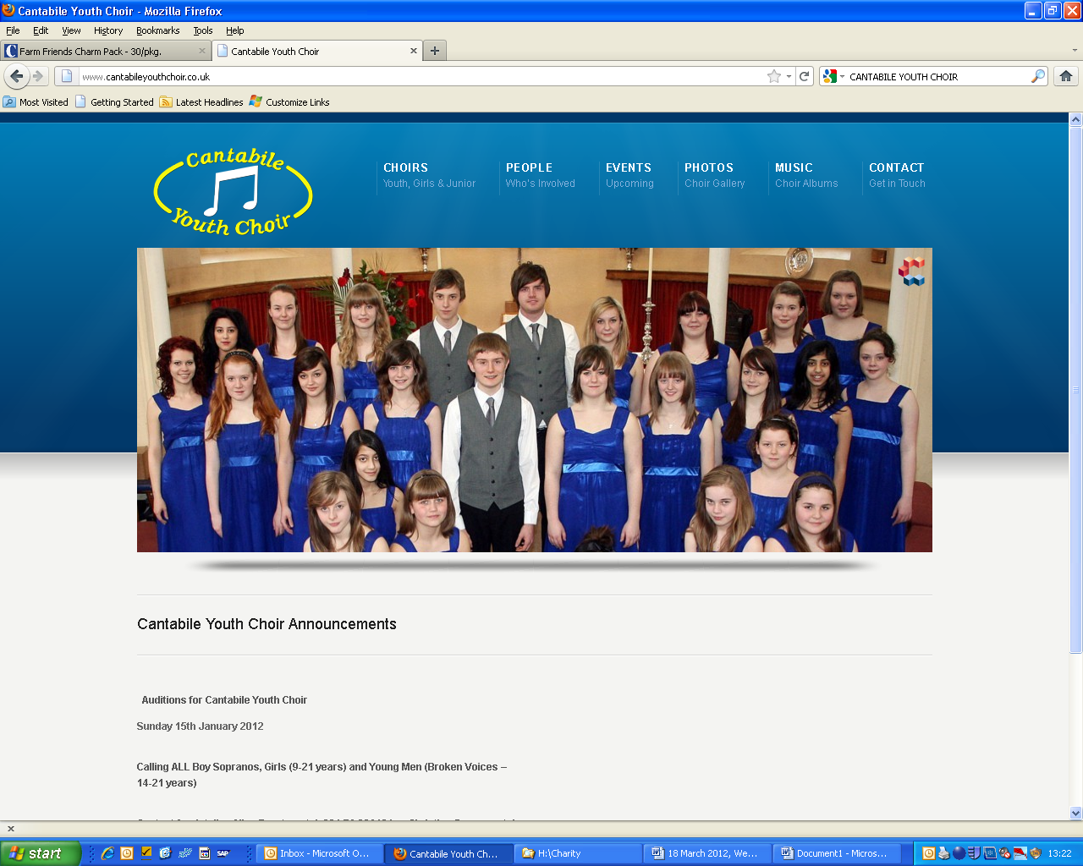  COFFEE MORNINGS are starting again on the last Saturday of the month. Please make a note of the following dates. We will be very grateful for offers of help, please see notice on the Church notice board! Thank you.  March 31 - April 28 - May 26 - June 30 - July 28 - August 25 - Sept 22 - Oct 27 - Dec 1  GOOD FRIDAY – 6TH April – 7.30 pm – A meditation in words and music for Holy Week featuring music of Bach, Handel and Somerville.  Soloist: Hilary Wade  Trinity Augmented Choir  Conductor: David Wilberforce  Organist: David Wilks  Narrator: Christine Waddington  Superintendent Minister: Rev Mark Godfrey MA BA  DATE FOR YOUR DIARY – there will be a Jubilee Faith Picnic following the service on Sunday June 3rd.  TRINITY NOTICES - Please let Adele Goodall have any items for next week’s notices by Tuesday evening. Adele can be contacted on 01423 525081 or e-mail adele.goodall@ntlworld.com |  | TRINITY METHODIST CHURCH, HARROGATE  www.trinityharrogate.org.uk  A crèche is available for any children who wish to join them during the service.  SUNDAY 18TH MARCH – LENT 4 – MOTHER’S DAY  10:30 am Rev Mark Godfrey – Family Service  Stewards: Margaret Rodham & Lynda Dale  Readers: Dennis Oram & Lorna Sutch  Flowers: Jean Bainbridge  TUESDAY 20TH MARCH  12 noon Trinity Luncheon Club at Trinity  WEDNESDAY 21ST MARCH  02:30 pm Lent Meeting at West Park  07:45 pm House Fellowship Group – 53 Beckwith Road  THURSDAY 22ND MARCH  07.15 pm Banner Group at Trinity  07:30 pm Circuit Meeting at Trinity  FRIDAY 23RD MARCH  01:30 – 3:00 pm Trinity Tots at Trinity  07:30 pm Choir Practice at Trinity  SATURDAY 24TH MARCH 2012  06:00 for 07:30 pm Stewardship Meal at Trinity  SUNDAY 25TH MARCH 2012 – LENT 5  10:30 am Rev Mark Godfrey  CHRISTIAN AID WEEK - This year Christian Aid Week runs from 13th to 20th May. We have been very grateful to Ann and David Wilberforce who have organised the street collection for us over the last few years. We are looking for someone to take over this role. If you are interested in finding out more then please have a chat with Mark.  We have a list of those who have helped with the door to door collection in recent years. If you are unable to assist this year please let Mark know. If you interested in collecting this year but haven't done so before then again have a word with Mark in the next few weeks.  Nidd Valley Circuit Quizaid - All are welcome to Nidd Valley Circuit Quizaid, to be held at Park Grove Church at 7pm on Friday 23rd March. All members of the new circuit are invited for a light hearted evening to test your brain power. Teams of a 4 max, £5 per person to include supper. The money you raise at Quizaid could go towards supporting children who live in some of the world’s poorest communities to get a better education, which will help them out of poverty. For further information and to book your place contact Simon Brock on 01423 869941, simonbrock@btinternet..com  Minister – Rev Mark Godfrey – Tel: 503551 E-mail: revmgodfrey@gmail.com

