
TRINITY METHODIST CHURCH, HARROGATE
A crèche is available for any children who wish to join them during the service.
www.trinityharrogate.org.uk
SUNDAY 23rd JUNE 2019
10:30am Mr S Spain
Stewards: Lynda Dale & Anthea Shenton
Readers: Cliff Anderton & Dennis Oram
Organist: Lynn Watson Flowers: - Enid Massey

TUESDAY 25th JUNE 2019
12 noon Luncheon
7:15pm Steel band

FRIDAY 28th JUNE 2019
10:00am Trinity Tots

SUNDAY 30th JUNE 2019
09:00am Holy Communion with Rev B Clowes
10:30am Family Service with Rev B Clowes
Stewards: Margaret Moorhouse & Lucy M
Readers: Don Rolls & Derek Harper
Organist: Church Band Flowers: - Church Flowers

TRINITY NOTICES – Please let Tracey have any items for Sunday 30th June by Tuesday 25th. She can be contacted on **** or by e-mail at ****@talktalk.net Please note: notices are on the website each week. www.trinityharrogate.org.uk Please email with amends or additions. TRINITY IS ON FACEBOOK Search for Trinity Methodist Church, Harrogate. Please note the following week there will be no notices produced.
PRAYER TIME - each week a small group of people faithfully pray for the church, the preacher, the service and more at 10.15am in one of the side rooms for 5-10 minutes.
EARLY COMMUNION - Every month on the last Sunday of the month there is a small group who meet for a short, reflective communion service at 9am. All are welcome to join us.
HOUSE FELLOWSHIP GROUP – Next one on 17th July at 7.45pm 50 Bogs Lane, Harrogate, HG1 4EB.
COLLECTIONS FOR MAY - 5 May 251.05; 12 May 346.96; 19 May 253.73; 26 May 222.50
Total Collections for May including bank transfers = 1,829
Target to break even on operational expenditure = 2,820
HARROGATE HOMELESS PROJECT have forwarded some advice with regard to how to respond to begging …. This can be a tough dilemma for people whose faith directs them to help the poor. The fact is that giving to someone who is begging can cause more problems than it cures. They advise to steer them to the help available.
• Springboard (next to Wesley Chapel, Oxford Street – access at rear).
Springboard is a drop in service every weekday between 09.30am to 2.00pm. It’s open to all. As well as advice and support, people can get a free two course lunch and refreshments. There are also shower and laundry facilities and our emergency accommodation team is based at Springboard, ready to support anyone in need of accommodation. Springboard also hosts other services, including a weekly GP service.
• St Peters Church breakfast club and evening food parcels.A free breakfast is served from 8.30am to 9.00am Monday to Saturday.
Free food parcels are given out at 5pm Monday to Saturday and 6pm on Sundays.
• Wesley Sunday Lunch Bunch (Wesley Centre Lower Hall)
1st, 2nd, 4th & 5th Sundays from 1-2pm. 3rd Sunday at St Peter’s Church 12.30pm. Free 2 course meal plus tea/coffee.
Minister – Rev Ben Clowes – Tel: 870977 E-mail: revbclowes@gmail.com
Children’s & Families Worker : Jaynie Kendall

• Tuesday Meals by Life Destiny Church (Wesley Centre Lower Hall)
6.30pm – 7.30pm Hot evening meal.
Boston Spa Methodist Church – An evening with Graham Kendrick “Keep the Banner Flying High” on Friday 28th June at 7:30pm
WORSHIP: FOUNDATIONS an introduction to preparing and leading worship in the Methodist Church at Bilton Area Methodist Church at 7:30pm on 27 June, 11 July & 18 July. Led by Mr Andrew Brown and Rev Ann Fox. To register email ann.fox@methodist.org.uk
Bilton have organised a bus for Grace’s ordination at Coventry Central Hall at 4pm on 30th June. There are 5 spaces left on the bus and a few more tickets, so if you are planning on going and need a ticket or transport, please contact Judith Dewhirst asap. The KNITTED BIBLE will be at Gracious Street from 2nd to 7th July. Entry is free and the exhibition is well worth seeing. Refreshments will be available at the Bridge café. There is more information on the poster on the notice board in the hall.
THE CALL - A CIRCUIT CELEBRATION on Saturday 6th July 7.30 p.m. At the Wesley Centre, Oxford street Harrogate. Tickets £7.50. JOIN THE CALL CHOIR AND SING ON THE NIGHT. Choir workshop on Wednesday 26th June 6.30 p.m. To 9.30 p.m. £10 to include music and rehearsal CD. Wesley Centre.
The Call is a time of worship, music and story, exploring Our Calling, with worship leader, Matt Beckingham and The Call Choir. Interval refreshments will be served. RESERVE YOUR TICKETS ON LINE.......thecalltour.com.
Minister – Rev Ben Clowes – Tel: 870977 E-mail: revbclowes@gmail.com
Children’s & Families Worker : Jaynie Kendall
Community and Outreach Lay Worker at The Methodist Church in Pocklington. The post is funded for three years and will initially be based at Pocklington Methodist Church. Salary £20,000, based on 37 hour week Closing Date: 14th July 2019 Rev Neville Simpson, Tel No. 01759 303354. Email: revnevillesimpson@gmail.com
ENCIRCLED IN CARE, A course for all, looking at areas where we can improve our care for one another. The six sessions will be held at Trinity 7.15 pm - 8.45 pm on the following dates:- Tuesday 21st May, Wednesday 5th June, Wednesday 12th June and Thursday 20th June. If you are interested please sign on the list in the foyer. Many thanks.
FLOURISH You can now make bookings for Flourish tickets here: (free) https://www.eventbrite.co.uk/e/flourish-the-yorkshire-north-east-district-weekend-tickets-55019533907?aff=eac2 Friday 18 Oct 19:30 to Sun 20 Oct 13:00 at Scarborough Spa YO11 2HD

The Sound of Silence
A district day to explore and reflect on the Cistercian tradition and the life and writings of Aelred, abbot of Rievaulx (1147-1167)
Saturday July 20th 2019 10 am – 4 pm
based at the Methodist Chapel in Rievaulx with admission to the Abbey.

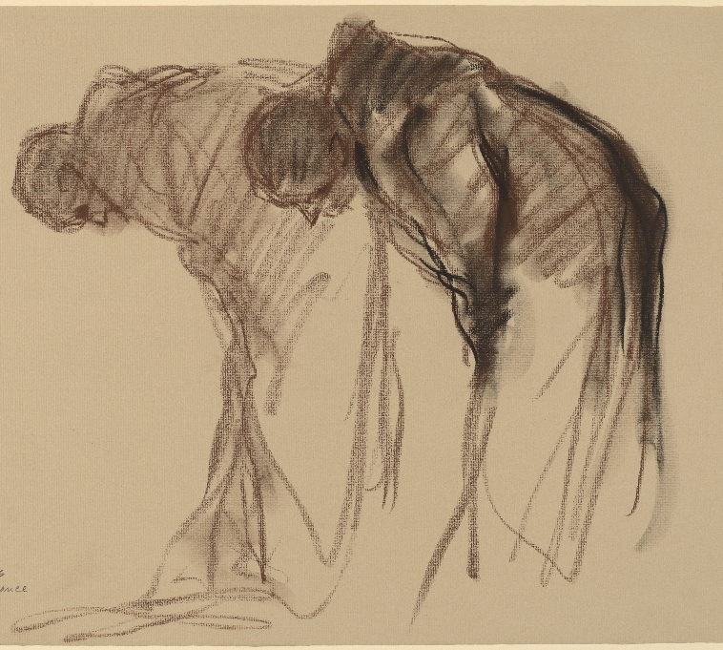
Abbaye de Solesmes. Stanley Rosman Used by permission
The day will be led by the Revd. Dr. Kenneth Carveley who is a church historian and liturgist with the Mirfield Liturgical Institute and a Cistercian scholar who has researched and taught the Cistercian tradition over many years.
Cost £5 per person. Parking: There is limited parking at the chapel, and further parking at the Abbey. Lunch : bring your own picnic lunch, tea and coffee will be available, or use the café at the Abbey.
Book with Siân Henderson at the Yorkshire North & East District Office, 28 The Green, Acomb, York, YO26 5LR. admin@yorkshirenemethodist.org. 01904 786275

