
TRINITY METHODIST CHURCH, HARROGATE
A crèche is available for any children who wish to join them during the service.
www.trinityharrogate.org.uk
SUNDAY 7th APRIL 2019
10:30am Rev C Lake
Stewards: Lynda Dale & Margaret Rodham
Readers: Anthea Shenton & Mary Briggs
Organist: Jean Clay Flowers: - Lorna Sutch

TUESDAY 9th APRIL 2019
12 noon Luncheon Club
7:15pm Steel band

WEDNESDAY 10th APRIL 2019
7:45pm House Fellowship Group

FRIDAY 12th APRIL 2019
10:00am Trinity Tots

SATURDAY 13th APRIL 2019
10:00 Coffee morning including bric a brac sale to raise money for Action Children (charity for Methodist church)

SUNDAY 14th APRIL 2019 Palm Sunday
10:30am Rev R Hicks
Stewards: Sue Covill & Carol Allan
Readers: Ann Francis & Dennis Oram
Organist: Jean Clay Flowers: - Stef Noble
4:00pm Messy Church with Rev B Clowes

TRINITY NOTICES – Please let Tracey have any items for Sunday 14th April by Tuesday 9th. She can be contacted on **** or by e-mail at ****@talktalk.net Please note: notices are on the website each week. www.trinityharrogate.org.uk Please email with amends or additions. TRINITY IS ON FACEBOOK Search for Trinity Methodist Church, Harrogate.
PRAYER TIME - each week a small group of people faithfully pray for the church, the preacher, the service and more at 10.15am in one of the side rooms for 5-10 minutes.
EARLY COMMUNION - Every month on the last Sunday of the month there is a small group who meet for a short, reflective communion service at 9am. All are welcome to join us.
HOUSE FELLOWSHIP GROUP – Next one on 10th April at 7.45pm 50 Bogs Lane, Harrogate, HG1 4EB. Future ones 22nd May; 19th June and 17th July.
Starbeck Methodist Church, the last concert of the winter season.
Saturday 13th April, 7.30pm; Harrogate Band in Concert ; Admission £8.00, children free.
For further information see notice board in entrance.
Invitation to your Church – The People’s Passion – Sunday 14th April (Palm Sunday) at 3pm.
A powerful piece of theatre and worship. From the roaring crowd at the entry into Jerusalem to the moving drama of the crucifixion, a chorus of voices tell the Easter story. There’s a part for everyone to play and no rehearsal needed. Suitable for adults and children so long as they can read, this is led by the renowned Riding Lights Theatre Company from York, who will be our resident drama team for the event. We are offering free tickets for the afternoon as a way of marking Palm Sunday together, available from 1 March on the booking site at http://www.springharvest.org/harrogate
Hampsthwaite are replacing their chairs and would like to offer theirs to anyone who can use them, churches, community groups, individuals. Grace Cauldwell, Methodist Minister- Nidd Valley Circuit
01423 562542; 07341 960506

Less than two weeks to go! If you’ve already booked to join us, or if you haven’t yet, we can promise you some great teaching, worship, children and youth programmes all in the comfort of the Harrogate Convention Centre, 13-17 April.
Don't forget our special Harrogate offer if you spread the word! If you have already booked for the full event, please then share the news about the event with a friend or relative. If they then book for the whole Harrogate break, they will get 10% off their booking - and you will also get 10% off your existing booking too!
To take advantage of this exciting offer, ask your friends to book online, then call us on 01825 769000 with your and their details to claim your 10% refund.

The Sound of Silence
A district day to explore and reflect on the Cistercian tradition and the life and writings of Aelred, abbot of Rievaulx (1147-1167)
Saturday July 20th 2019 10 am – 4 pm
based at the Methodist Chapel in Rievaulx with admission to the Abbey.

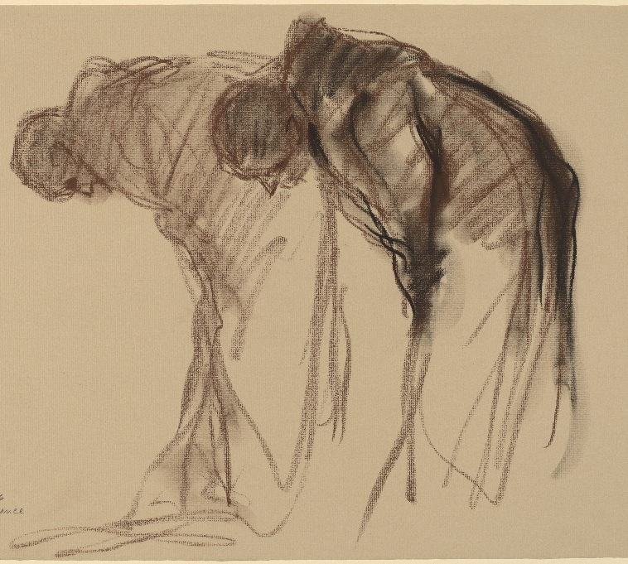
Abbaye de Solesmes. Stanley Rosman Used by permission
The day will be led by the Revd. Dr. Kenneth Carveley who is a church historian and liturgist with the Mirfield Liturgical Institute and a Cistercian scholar who has researched and taught the Cistercian tradition over many years.
Cost £5 per person. Parking: There is limited parking at the chapel, and further parking at the Abbey. Lunch : bring your own picnic lunch, tea and coffee will be available, or use the café at the Abbey.
Book with Siân Henderson at the Yorkshire North & East District Office, 28 The Green, Acomb, York, YO26 5LR. admin@yorkshirenemethodist.org. 01904 786275

Full event and day tickets are available here.
[https://www.ecevents.uk/ec-sh-harrogate-2019/harrogate-booking/Site/Register]
Coffee Morning Saturday 27th April During the coffee morning we will be showing the recording of the 100Th anniversary ‘’Songs of Praise’’ service led by our then minister the Rev Leslie Goy. The showing will start at 10.30 a.m. until 11.30 a.m. and coffee will be served from 10.00 a.m. as usual.
SAVE THE DATE – The Call. On Saturday 6th July 2019, the Nidd Valley Circuit will host The Call tour at Wesley Centre.
An evening of music and celebration led by musician, composer and worship leader, Matt Beckingham
Please put this date in your diary. More details to follow.....
FLOURISH You can now make bookings for Flourish tickets here: (free) https://www.eventbrite.co.uk/e/flourish-the-yorkshire-north-east-district-weekend-tickets-55019533907?aff=eac2 Fri 18 Oct 19:30 to Sun 20 Oct 13:00 at Scarborough Spa YO11 2HD
Minister – Rev Ben Clowes – Tel: 870977 E-mail: revbclowes@gmail.com
Children’s & Families Worker : Jaynie Kendall

