
TRINITY METHODIST CHURCH, HARROGATE
A crèche is available for any children who wish to join them during the service.
www.trinityharrogate.org.uk
SUNDAY 9th JUNE 2019
10:30am Rev G Houghton
Stewards: Mary Briggs & John Batchelor
Readers: Hannah Morris & Jane Shaw
Organist: Judith Yeats Flowers: - Church
4:00pm Messy Church – Mr S Spain

TUESDAY 11th JUNE 2019
12 noon Luncheon
7:15pm Steel band

FRIDAY 14th JUNE 2019
10:00am Trinity Tots

SUNDAY 16th JUNE 2019
10:30am Rev B Clowes
Stewards: Sue Covill & Margaret Moorhouse
Readers: Ann Francis & Sue Covill
Organist: Philip Goodwin Flowers: - Marion Green

TRINITY NOTICES – Please let Tracey have any items for Sunday 16th June by Tuesday 11th. She can be contacted on **** or by e-mail at ****@talktalk.net Please note: notices are on the website each week. www.trinityharrogate.org.uk Please email with amends or additions. TRINITY IS ON FACEBOOK Search for Trinity Methodist Church, Harrogate. Please note the following week there will be no notices produced.
PRAYER TIME - each week a small group of people faithfully pray for the church, the preacher, the service and more at 10.15am in one of the side rooms for 5-10 minutes.
EARLY COMMUNION - Every month on the last Sunday of the month there is a small group who meet for a short, reflective communion service at 9am. All are welcome to join us.
HOUSE FELLOWSHIP GROUP – Next one on 19th June at 7.45pm 50 Bogs Lane, Harrogate, HG1 4EB. Future ones 17th July.
TRINITY TIMES Please can you forward anything for this by Sunday 9th June to Muriel Riley
CHURCH COUNCIL MEMBERS I am required to give you notice and ask for your attendance at Trinity Methodist Church for a meeting of the Church Council at 7:30pm on Thursday 20th June. Any AOB should be with Rev Ben Clowes no later than 24 hours prior to this meeting. Please advise if you are unable to attend. Thank you. Adele Goodall Church Council Secretary.
THE CALL - A CIRCUIT CELEBRATION on Saturday 6th July 7.30 p.m. At the Wesley Centre, Oxford street Harrogate. Tickets £7.50. JOIN THE CALL CHOIR AND SING ON THE NIGHT. Choir workshop on Wednesday 26th June 6.30 p.m. To 9.30 p.m. £10 to include music and rehearsal CD. Wesley Centre.
The Call is a time of worship, music and story, exploring Our Calling, with worship leader, Matt Beckingham and The Call Choir.
Interval refreshments will be served. RESERVE YOUR TICKETS ON LINE.......thecalltour.com.
The “Chorus Crew” in Concert - Folk Songs & Sea Shanties
The Chorus Crew have been singing together for about three years now. We perform regularly in the Harrogate and Knaresborough district, singing a wide range of unaccompanied folk songs and sea shanties. We love singing for an audience, sharing information about the songs, and encouraging audience participation. Sunday 2nd June 2019 @ 3.00pm Admission £5 Children Free - Pay at the door In aid of All We Can - Light refreshments - Everyone is most welcome.
Minister – Rev Ben Clowes – Tel: 870977 E-mail: revbclowes@gmail.com
Children’s & Families Worker : Jaynie Kendall
Bilton have organised a bus for Grace’s ordination at Coventry Central Hall at 4pm on 30th June. There are 5 spaces left on the bus and a few more tickets, so if you are planning on going and need a ticket or transport, please contact Judith Dewhirst asap.

The Sound of Silence
A district day to explore and reflect on the Cistercian tradition and the life and writings of Aelred, abbot of Rievaulx (1147-1167)
Saturday July 20th 2019 10 am – 4 pm
based at the Methodist Chapel in Rievaulx with admission to the Abbey.

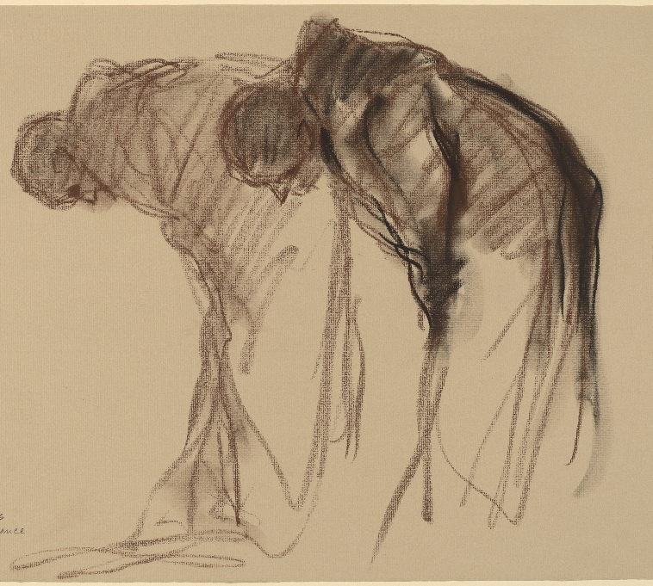
Abbaye de Solesmes. Stanley Rosman Used by permission
The day will be led by the Revd. Dr. Kenneth Carveley who is a church historian and liturgist with the Mirfield Liturgical Institute and a Cistercian scholar who has researched and taught the Cistercian tradition over many years.
Cost £5 per person. Parking: There is limited parking at the chapel, and further parking at the Abbey. Lunch : bring your own picnic lunch, tea and coffee will be available, or use the café at the Abbey.
Book with Siân Henderson at the Yorkshire North & East District Office, 28 The Green, Acomb, York, YO26 5LR. admin@yorkshirenemethodist.org. 01904 786275

Hampsthwaite are replacing their chairs and would like to offer theirs to anyone who can use them, churches, community groups, individuals. Grace Cauldwell, Methodist Minister- Nidd Valley Circuit
01423 562542; 07341 960506
ENCIRCLED IN CARE, A course for all, looking at areas where we can improve our care for one another. The six sessions will be held at Trinity 7.15 pm - 8.45 pm on the following dates:- Tuesday 21st May, Wednesday 5th June, Wednesday 12th June and Thursday 20th June. If you are interested please sign on the list in the foyer. Many thanks.
FLOURISH You can now make bookings for Flourish tickets here: (free) https://www.eventbrite.co.uk/e/flourish-the-yorkshire-north-east-district-weekend-tickets-55019533907?aff=eac2 Friday 18 Oct 19:30 to Sun 20 Oct 13:00 at Scarborough Spa YO11 2HD

